

The Future of Vocational Rehabilitation

Stephen Wooderson
CEO
Council of State Administrators of Vocational Rehabilitation
23RD Annual GWU Rehabilitation Counseling Symposium
March 24, 2023

Thank you!

- CSAVR and our Operating Principles
- Acknowledging our Present
- CSAVR Priorities
- Embracing the Future

Council of State Administrators of Vocational Rehabilitation

- We tell the story of the public VR program!
- Non-profit membership organization
- Governed by the State VR Directors
- Represent all employees of the federal/state vocational rehabilitation programs
- Provide legislative advocacy and knowledge exchange/networking for members
- Created and manage the National Employment Team and Talent Acquisition Portal
- Headquartered in the Washington, DC – 6 staff across the country – supported by our network of State VR agencies

CSAVR Operating Principles

VR is driven to deliver inclusive, culturally informed services and outcomes for people with disabilities and business in a system that is free of ableism, racism, discrimination, and institutional bias.

Operating Principles

- Principle #1: Innovating Solutions to achieve greater access to and use of vocational rehabilitation services resulting in the most effective outcome for our customers.
- Principle #2: Building careers and retaining talent in America’s workforce by investing expertise and resources to benefit our customers.
- Principle #3: Customizing Services and Expertise that provide flexible supports and services to meet the workforce goals of our customers.
- Principle #4: Leading and Engaging in Collaborative Strategies with our partners who are working with us to achieve greater collective impact at all system levels.
- Principle #5: Committed to assuring the promotion of diversity, equity and inclusion for Black, Indigenous, People of Color and all who are legally protected from discrimination.

Honoring our Past 100 Year Legacy

The Public VR Program has and must continue to evolve through Innovation

Acknowledging our Present - The Vision for the Public VR Program

Increasing the workforce participation rate of persons with disabilities

Acknowledging our Present - Celebrations!

- Increase in measurable skills gain
- Increase in finishing programs and attaining credentials
- Increase in the number of students with disabilities receiving supports
- More than 50% of our individual customers are under age 25
- Fewer SVRA’s with wait lists (OOS)

Acknowledging our Present - Innovation!

- State specific projects – DIF and Career Pathways initiatives
- Customer engagement strategies – rapid engagement and business services
- Recruitment and retention strategies – VR professionals
- Capacity building strategies – community and education

Acknowledging our Present - CSAVR Priorities!
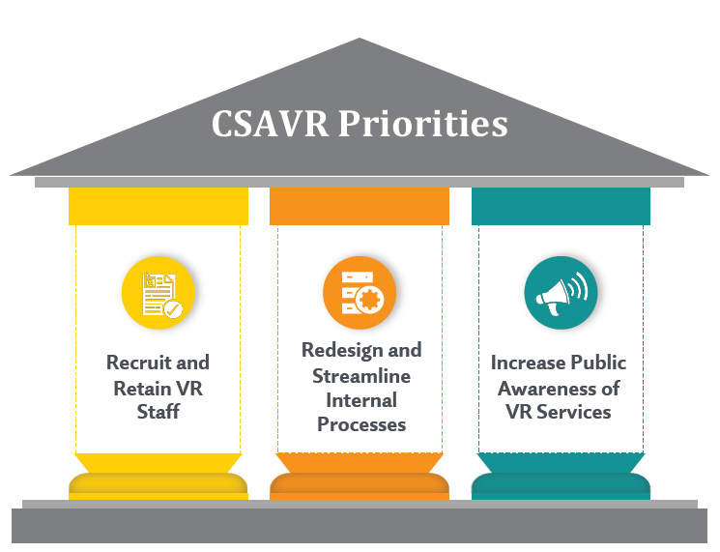

- Recruit and Retain VR Staff
- Redesign and Streamline Internal Processes
- Increase Public Awareness of VR Services

Acknowledging our Present - Priority #1

Recruit and Retain VR Staff
- Recruitment
  - Candidate Pipeline (University and RSA strategies)
- Retention
  - Salary studies (CSAVR and Researcher strategies)
  - Employee Satisfaction (Researcher and SVRA strategies)

Acknowledging our Present - Priority #2

Redesign and Streamline Internal Processes
- Examine the VR Customer Service Continuum
- Establish a VR Process Improvement COP
- Identify top process constraints

Acknowledging our Present - Priority #3

Increase Public Awareness of VR Services
- Improve awareness of oversight authorities (CSAVR and Researchers)
- Promote a national brand
- Communicate to our market

Embracing our Future

Where do you fit - Students? Grads?? Intern supervisors??? Educators????

Keeping an Eye on What Matters
- Fiscal and Program Performance
- Profession and Community
- Critical Thinking and Innovation

Embracing our Future - Fiscal and Program Performance

What matters?
- The efficiency and efficacy of federal funds utilization
- Increase in the workforce participation rate of people with disabilities (CIE)

Embracing our Future - Profession and Community

High Impact Areas
- Preservice preparation of professionals
- Hiring, onboarding and retention of professionals
- Community and business partnerships

Embracing our Future - Critical Thinking and Innovation

Why Critical Thinking?
- CT is a LEARNED ABILITY. Universal features? YES! But inherit for all? NO!
- To innovate – must be able to synthesize and create new pathways to solutions
Our profession demands new solutions in order to continue to evolve
- Commit to CT – find your personal and professional pathway
Our society demands new solutions
- Intersectionality
- Social and Racial Justice

Closing Bits

- Don’t let perfection become the enemy of good
- Don’t let urgency distract from thoughtful intent
- Don’t let symptoms overshadow root cause
- Do good work today, and tomorrow will yield results

Thank You

Steve Wooderson
swooderson@csavr.org
202-604-7880



