

Return on Investment in Vocational Rehabilitation: A Primer
Made possible by a grant from the National Institute on Disability, Independent Living, and Rehabilitation Research #90IFDV0028.
Lesson 3: Applied Examples

Overview and Instructions

Overview
Lesson 1 explained the basic terminology of ROI as well as some ethical considerations in using ROI data.

In Lesson 2, you were introduced to the VR ROI Project and its approach to estimating ROI for VR programs

Lesson 3 provides you with illustrative examples and practical application so that you can apply your new ROI knowledge to your role as a VR professional, stakeholder, policymaker or researcher!

Beginning Instructions
The VR ROI 101 Lessons are intended to provide useful information regarding Return on Investment concepts.

The intent is to use all three lessons
- (1 – Basic Terminology, 2 – The VR ROI Project, and 3 – VR ROI applied examples)
to enhance your understanding of ROI and your confidence in accurately applying ROI concepts in your work setting.

Continuing Education Credit
You may use the VR ROI 101 Lessons to expand your knowledge of this topic and to earn continuing education credits.

When you complete all 3 ROI 101 lessons, complete the evaluation and earn 2 CRC (Certified Rehabilitation Counselor) continuing education hours.

Once you complete the survey, your certificate will be available for download.

These credits are pre-approved by the Commission on Rehabilitation Counselor Certification. You can also submit your CRC Credit Certificate for post-approved credit with other licensure or certifying bodies.

Review of Lessons 1 & 2
Lesson 1 focused on ethical considerations in using ROI data; key definitions of ROI terms; and advantages and disadvantages of various ways to report ROI.

Lesson 2 described the key features of the VR ROI Project approach to estimating ROI:
- Uses readily-available administrative data
- Estimates VR’s impact from when services begin
- Estimates longitudinal VR impacts on employment & earnings
- Examines VR’s impact for individuals with different disabilities
- Examines impact of specific types of VR services
- Uses rigorous statistical model
- Estimates both service costs and VR impacts at the individual level

The following examples illustrate many of these key features

Applied Examples to Illustrate Features of the VR ROI Model

VR ROI Feature # 3 (1 of 4): Estimate Longitudinal VR Impacts
Recall from Lesson 2 that the VR ROI project uses up to 3 years of pre-VR employment & earnings and at least 5 years of post-application data

To illustrate the importance of such longitudinal earnings, the next two slides display the earnings impact of a 1988 pilot demonstration for transitioning youth, PERT.

Additional information about PERT and its evaluation can be found in citations included at the end of this presentation.

VR ROI Feature # 3 (2 of 4): Estimate Longitudinal VR Impacts
PERT (Postsecondary Education Rehabilitation and Transition) is a collaborative effort between the Virginia’s VR agency, Wilson Workforce Rehabilitation Center (WWRC), and the Department of Education.

It’s for high school students with disabilities who are selected by local school divisions.

PERT provides a 12-day, in-residence, comprehensive career and independent living skills assessments assessment at WWRC.

A follow-up report is shared with the student and family, the VR agency, and the school.

The report is implemented during remaining high school years and the student might receive subsequent VR services.

VR ROI Feature # 3 (3 of 4): Estimate Longitudinal VR Impacts

Chart 1 to the right represents earnings during the Year of PERT and Non-PERT participants
The vertical axis of the chart represents the Mean Earnings in Dollars for 2002.

The horizontal axis of the chart represents the Year relative to the time of application for VR services, plus or minus year(s) relative to FY 1988

This chart illustrates the importance of longitudinal earnings for transitioning youth as well as human capital services. (Source: Ashley et al., 2006)

VR ROI Feature # 3 (4 of 4): Estimate Longitudinal VR Impacts

PERT clients come into the program with lower average earnings

This continues for four years after the 12-day assessment as PERT clients complete high school and, possibly, additional training and VR Services.

In the fifth year, that changes as PERT clients earn more and that gap increases over the next several year.

VR ROI Features # 4 & 5 (1 of 3): Estimated Impacts by Service & Disabling Condition
To illustrate the importance of accounting for disabling conditions (key feature #4) and service types (key feature #5), the following slides discuss employment and earnings impacts as estimated from the VR ROI model for a cohort of individuals applying to Virginia DARS during State Fiscal Year 2000:
- For each of 3 separate disability types (one slide with charts and a second with discussion of the charts)
- For 6 separate types of service, DTERMO (using an earlier service categorization where O represents “Other”)
- For the first 2 years following application (short run) and more than 2 years following application (long run)

VR ROI Features # 4 & 5 (2 of 3): Estimated Impacts by Service & Disabling Condition
General notes on interpretation
- Although these slides illustrate key features 4 & 5, the results were estimated through the VR ROI model which includes all 7 features.
- Labor market impacts are relative to a comparable individual who did not receive the service (after “holding other factors constant”).
- Labor market impacts are measured as changes from the two years prior to application. This adds another level of control for individual traits affecting labor market success that are not among those included in the model (e.g., demographics, education, etc.). Economists refer to these as “unobservable variables” (e.g., work ethic, family support).

Interpreting a couple of hypothetical results:
- 0.1 for employment: If 10% of non-recipients were employed, then 20% of individuals of those receiving the service would be employed.
- 0.1 for earnings: Once employed, those receiving the service have 10% higher earnings than those who did not.

VR ROI Features # 4 & 5 (3 of 3): Estimated Impacts by Service & Disabling Condition
General notes on interpretation (cont’d)
- Model allows for the receipt of any combination of services, including none at all.
  - An individual is in the “treatment” group for those services received and in the “comparison” group for those not received. This is a powerful statistical feature.
- Short run (SR) is defined as within two years of application, a period during which 75% of cases are closed. Thus, the SR might be thought of as the period of service receipt by some individuals and the LR as predominantly post-service.
  - Different patterns of SR and LR market impacts are observed for each disabling condition.
  - Unsurprisingly, the largest differences are for human capital development such as Education and Training.

Service Effects on Labor Market Outcomes for People with Mental Illness (1 of 4) (DARS SFY 2000 Applicants)

Note: Vertical axis shows change in employment rate or proportionate change in earnings (if employed). Horizontal axis shows different service types

Service Effects on Labor Market Outcomes for People with Mental Illness (2 of 4) (DARS SFY 2000 Applicants)

Impact of Short Run (SR – within two years of application)
- With the exception of the very strong employment impacts of Training, SR impacts are relatively modest and actually negative in some cases.
  - Not terribly surprising because this is the primary period of service provision.
  - Education has the strongest negative impacts on both employment (11% lower) and earnings (9% lower). Plausibly, students are in school and, if working, are likely to work in lower-paid, part-time jobs

Service Effects on Labor Market Outcomes for People with Mental Illness: Long-Run Impacts (3 of 4) (DARS SFY 2000 Applicants)

Impacts in the Long-Run (LR, more than two years after application)
- LR results are quite different and generally stronger than in the SR. In particular, LR earnings impacts are positive and higher than SR impacts for every service type.
- Recipients of Education, Restorative, Maintenance, and Other services are employed at roughly the same rates as non-recipients but have higher paying jobs with earnings ranging from 12% to 21% higher.
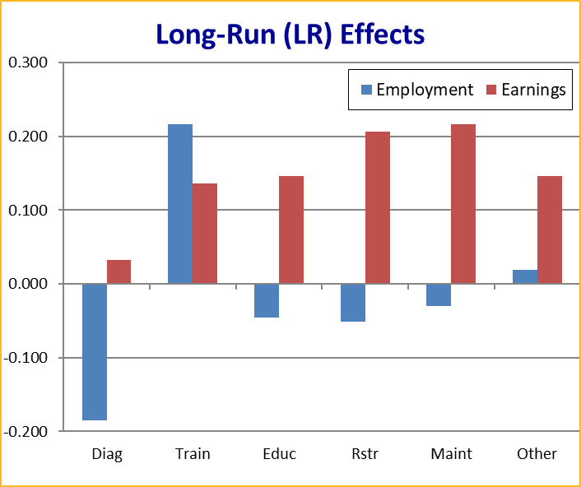

Service Effects on Labor Market Outcomes for People with Mental Illness: Long-Run Impacts (4 of 4) (DARS SFY 2000 Applicants)
Impacts in the Long-Run (LR, more than two years after application)
- Training provides the strongest impacts: Not only more likely be employed (21% higher likelihood), but also higher earnings (12%).
- Diagnostic & Evaluation services are estimated to have negative impacts on employment rates (19% lower) at comparable earnings levels.
  - Plausible to have no effect but the lower employment likelihood is anomalous.
  - A sizable proportion of individuals with mental illness (MI) are referred through Community Service Boards (CSBs) and arrive at DARS with full diagnostic information. DARS believes this anomalous result indicates that individuals who are not connected to CSBs fare worse than those who are. A potential policy recommendation is for DARS to work more closely with CSBs.

Service Effects on Labor Market Outcomes for People with Cognitive Impairments (1 of 3) (DARS SFY 2000 Applicants)
Note: Vertical axis shows change in employment rate or proportionate change in earnings (if employed). Horizontal axis shows different service types

Service Effects on Labor Market Outcomes for People with Cognitive Impairments (2 of 3) (DARS SFY 2000 Applicants)
Impacts in the Short-Run vs. Long-Run.
- Diagnostic, Training, Education, and Other services have positive SR and LR labor market impacts.
- Restorative and Maintenance services have negative labor market SR and LR labor market impacts.
- In general, LR impacts are stronger (bigger positive or smaller negative) than SR impacts.

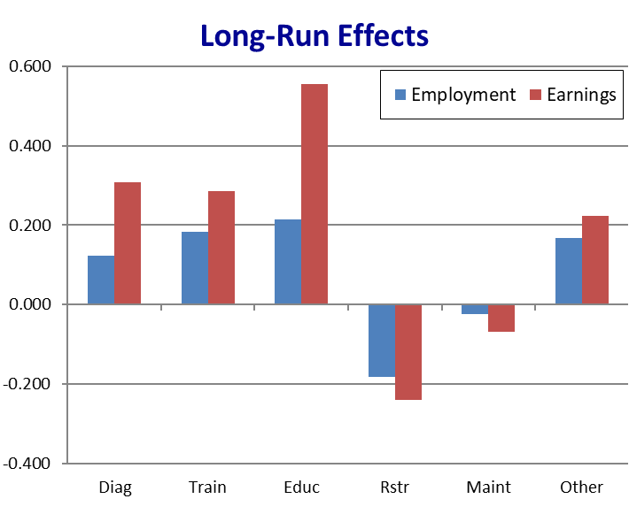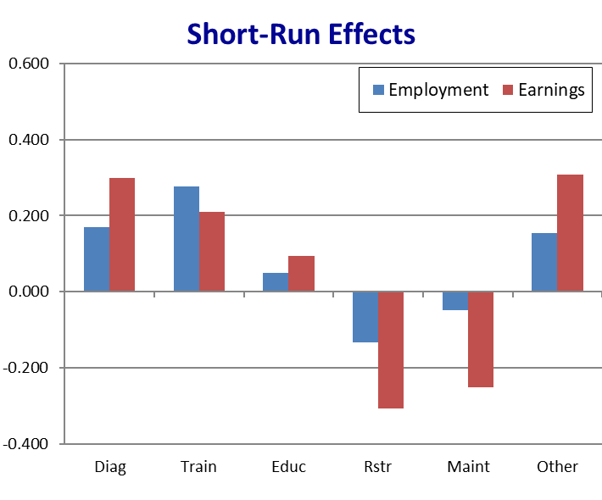

Service Effects on Labor Market Outcomes for People with Cognitive Impairments (3 of 3) (DARS SFY 2000 Applicants)
Impacts in the Short-Run vs. Long-Run.
- Education appears to have the strongest positive LR impacts. However, that impact is limited to the 3.4% of the cohort who received the service.
- Restoration has small LR negative impacts and it was provided to 21% of individuals with cognitive impairments (CI).

Service Effects on Labor Market Outcomes for People with Physical Impairments (1 of 3) (DARS SFY 2000 Applicants)

Note: Vertical axis shows change in employment rate or proportionate change in earnings (if employed). Horizontal axis shows different service types

Service Effects on Labor Market Outcomes for People with Physical Impairments (2 of 3) (DARS SFY 2000 Applicants)
Service impacts stronger for customers with physical impairments (PI) than for other disabling conditions
- True in both short-run and long-run, although LR impacts are generally stronger than SR.
- Again, earnings impacts increase more from SR to LR than do employment impacts.

Service Effects on Labor Market Outcomes for People with Physical Impairments (3 of 3) (DARS SFY 2000 Applicants)
All but one SR and LR impact is positive
- The exception is Maintenance which has a negative SR earnings impact. Maintenance impacts are small in the LR.

All other service types show strong positive LR impacts for both employment and earnings.
- Education and Restoration appear to have the strongest impacts.
…

VR ROI Feature # 6: Rigorous Statistical Model
Review of material from Module 2
- Ideally, we would observe the same person with and without VR services over the same time period, but this is not possible.
- To get closer to that ideal, estimated results:
  - Control for observed explanatory variables (e.g., gender, education, race, disability, local labor market conditions)
  - Partially control for “unobservable” explanatory variables (e.g., work ethic, family support) by using pre-VR employment and earnings as a “baseline”
  - Employ state-of-the-science statistical controls to ensure that the outcomes are the result of VR rather than other factors. For a detailed discussion, see Dean, et al., 2015 through 2018.

How does the VR ROI approach affect estimates of VR service effects?
- Charts on next screen show effects estimated by a simple model that compares service recipients vs. non-recipients and those estimated by the VR ROI model that includes all 7 features

Service Effects for People with Mental Illness (DARS SFY 2000 Applicants): Simple Comparisons vs. VRROI Model
Vertical axis is the impact to employment and earnings. Horizontal axis are different time periods.

In the simple model services are estimated to raise employment but with lower earnings in those jobs. This indicates that the VR story is one of employment gains.

The VR-ROI model presents a very different and more nuanced picture:
- The earnings effects are strongly positive for all services;
- The employment effects are positive for some services but negative for others.

VR ROI Feature # 7 (1 of 4): Estimates Made at Individual Level
Review of material from Module 2
- The model estimates employment & earnings impacts as well as service costs at the individual level
  - Provides the flexibility to obtain ROI estimates for different client groups by “aggregating” them for the entire agency or by a disability

The next three slides use a cohort of SFY 2000 applicants to Virginia DARS and show ROI/ROR estimates for
- PERT, a collaborative transition program in Virginia
- Agency-wide ROI for Virginia DARS
- Three disability types among Virginia DARS applicants

VR ROI Feature # 7 (2 of 4): ROI of a Collaborative Transition Program
PERT (Post-secondary Education/Rehabilitation Transition) Program
- Comprehensive career and independent living skills assessments at WWRC for high school students with disabilities who are selected by local school divisions
- Community-based team implementation of assessment findings
- Participants may receive additional VR services following PERT participation

WWRC used results from the VR-ROI model to develop the following graphic for discussion with families considering the PERT program.

PERT Impact on Finding a Job and Income
- Increases chances of finding and keeping a job by 12%
- Combined with one more year of education the chance of getting and keeping a job increases by 38%
- After you find a job, participating in PERT will on average double the amount of a student’s earnings in the long run

VR ROI Feature # 7 (3 of 4): Virginia DARS VR ROI “Elevator Speech”
Individual estimates can be aggregated across disability and service types to calculate an agency-wide ROI.
- The following statement uses the “bang per buck” (benefit-to-cost) approach as discussed in the general ROI introduction above.
- The statement was written with state policy makers and other stakeholders in mind.

“For those VR applicants in 2000 who received VR services, 80% enjoyed earnings gains that exceeded the cost of their VR. For every $1,000 spent by DARS, the average (median) consumer earned $7,100 more over 10 years than they would have earned without VR services... And the top 10% earned $45,100 (or more) over the same period.”

VR – ROI Feature # 7 (4 of 4): Annualized ROR (IRR) by Disability Group
10-Year Rates of Return (Annualized) − Virginia DARS, SFY 2000 Applicants

 | Mental Illness (MI) | MI (no D&E*) | Cognitive Impairment | Physical Impairment
% with Negative ROR | 45% | 7% | 21% | 2%
ROR at Median | 3% | 40% | 35% | 141%
90th Percentile | 52% | 97% | 195% | 255%

*Diagnostic & Evaluation services; see explanation on next slide

Annualized ROR by Disability Group: Discussion
The table on the previous slide uses the Internal Rate-of-Return (IRR or ROR) approach as discussed in Module 1.
- These RORs combine benefits and costs for all services a customer receives.
- A positive value implies benefits of VR services exceed their costs.
- As discussed in Module 1, might compare these RORs to current interest rates for money market accounts or the long-term average ROR for the U.S. stock market.

Given the anomalous results for Diagnostic & Evaluation services in the MI cohort (see slide 16), the table provides a second set of ROR results that excludes D&E in the calculation. Readers can focus on the set of ROR results they believe to be most appropriate.

Conclusion
You have now completed Lesson 3 of this primer.
Please contact us if you require additional information!

References (1 of 2)
Additional information about PERT and its evaluation.
- Ashley, J., Dean, D., Rowe, K., & Schmidt, R. (2006). “The Long-Term Impact of Comprehensive Vocational Assessment for Youth with Disabilities in Transition: Evaluation of Virginia’s Post-Secondary Education/Rehabilitation Transition (PERT) Program.” Vocational Evaluation and Career Assessments Professionals Journal, 2(2), 14-32.
- Ashley, J. & Schmidt, R. (2016). “Investing in Career Opportunities for Youths with Disabilities.” Presentation to the Torch Club of Richmond, VA. PowerPoint found at vroi.org/resources

References (2 of 2)
Publications in academic journals discussing statistical issues, methodology, and results of the VR ROI model.
- Dean, D., Pepper, J., Schmidt, R., Stern, S. (2015). “The Effects of Vocational Rehabilitation for People with Cognitive Impairments.” International Economic Review, 56 (No. 2, May 2015), 399-426.
- Dean, D., Pepper, J., Schmidt, R., Stern, S. (2017). “The Effects of Vocational Rehabilitation for People with Mental Illness.” Journal of Human Resources, 52 (No. 3, Summer 2017), 826-858.
- Dean, D., Pepper, J., Schmidt, R., Stern, S. (2018). “The Effects of Vocational Rehabilitation for People with Physical Disabilities.” Journal of Human Capital, 12 (No. 1, Summer 2018), 1-37.

